

Project Interim Report

On

Energy Footprint Calculator

(Using Python, Data Science, and Sustainability Analytics)

RU-500-02-00002
Foundations of Machine Learning

SESSION: 2026-27

Submitted By
Sudeep Sarkar
RU-25-11468

Master Of Computer Application with AI and ML

Under the Guidance of Mr. Zamin Hamid

SCHOOL OF INFORMATION AND TECHNOLOGY RUNGTA INTERNATIONAL SKILLS UNIVERSITY
BHILAI, CG

(April 2026)

Abstract

The Energy Footprint Calculator is a comprehensive full-stack web-based application designed to analyze and estimate the environmental impact of daily human activities in terms of carbon emissions and water consumption. In the modern era, rapid industrialization, urbanization, and increased dependency on fossil fuels have led to significant environmental challenges such as global warming, climate change, air pollution, and water scarcity. These issues are further intensified by the lack of awareness among individuals regarding how their everyday lifestyle choices contribute to environmental degradation. Therefore, there is a growing need for accessible and easy-to-use systems that can help individuals understand and evaluate their ecological footprint.
This project aims to bridge this awareness gap by providing a simple, interactive, and user-friendly platform that enables users to calculate their environmental impact based on their daily consumption patterns. The system takes into account multiple input parameters such as electricity consumption (measured in kilowatt-hours), fuel usage for transportation (including petrol and diesel), LPG consumption for household energy, and food intake such as rice, wheat, chicken, and vegetables. Each of these inputs is associated with predefined environmental impact factors derived from scientific studies, global datasets, and research-based emission standards. These factors are used to compute both carbon emissions (in terms of CO₂ equivalent) and water footprint (in liters of water consumption).
The system is implemented using a modern client-server architecture, ensuring scalability, modularity, and efficiency. The backend of the application is developed using the Flask framework in Python, which handles HTTP requests, processes user inputs, and performs all necessary calculations. The backend is structured into multiple modules, including carbon calculation, water footprint estimation, data analysis, and recommendation generation. This modular design improves maintainability and allows easy future enhancements. The frontend is developed using HTML, CSS, and JavaScript, providing a responsive and visually appealing interface. It allows users to enter data easily and view results dynamically without requiring page reloads.
One of the key strengths of this system is its ability to present complex environmental data in a simplified and meaningful way. The calculated results are categorized into different segments such as energy usage, transportation, and food consumption, allowing users to identify the major contributors to their environmental footprint. The system also utilizes graphical representations such as pie charts and structured dashboards to enhance user understanding and engagement. This visualization approach makes the system not only functional but also educational.
In addition to calculation and visualization, the application includes a recommendation system that provides practical and actionable suggestions for reducing environmental impact. These suggestions are generated based on the user’s input data and encourage eco-friendly practices such as reducing electricity usage, minimizing fuel consumption, and adopting sustainable dietary habits.
Overall, the Energy Footprint Calculator serves as both an analytical and educational tool that promotes environmental awareness and sustainable living. It demonstrates the effective integration of full-stack web development technologies with environmental science concepts to address real-world problems. The project highlights how technology can be leveraged to influence positive behavioral change and support global sustainability goals. By providing users with accurate insights and meaningful recommendations, the system encourages responsible decision-making and contributes toward building a more environmentally conscious society.

Introduction

In recent decades, the world has witnessed rapid growth in population, urbanization, and industrial development. While these advancements have significantly improved the quality of life, they have also led to excessive consumption of natural resources such as energy, water, and fossil fuels. This overconsumption has resulted in serious environmental challenges, including global warming, climate change, air pollution, and water scarcity. Among these, the increase in greenhouse gas emissions, particularly carbon dioxide (CO₂), is one of the primary contributors to climate change, while unsustainable water usage has intensified the global water crisis.
In daily life, individuals consume electricity for household activities, use fuel for transportation, and rely on agricultural products for food. However, most people are unaware of the hidden environmental costs associated with these activities. For instance, electricity generation often depends on fossil fuels, leading to carbon emissions, while food production requires significant water resources, contributing to the overall water footprint. These indirect impacts are not immediately visible, making it difficult for individuals to evaluate their contribution to environmental degradation.
To better understand these impacts, the concepts of carbon footprint and water footprint are widely used. The carbon footprint measures the total greenhouse gas emissions caused directly or indirectly by human activities, whereas the water footprint measures the total volume of freshwater used in the production of goods and services consumed. These indicators provide a scientific and measurable approach to analyzing environmental impact.
Despite the availability of such concepts, there is a lack of simple and interactive tools that allow users to calculate and visualize their environmental footprint in a practical manner. Most existing tools are either complex, limited in scope, or lack user-friendly interfaces. Therefore, there is a need for an integrated system that combines calculation, visualization, and user interaction in a single platform.
The Energy Footprint Calculator is developed to address this need. It is a full-stack web-based application that enables users to estimate their environmental impact based on daily consumption patterns such as electricity usage, fuel consumption, LPG usage, and food intake. The system processes these inputs using predefined environmental factors and calculates both carbon emissions and water footprint, presenting the results in a structured and meaningful way.
The application is built using a client-server architecture, where the backend is implemented using the Flask framework in Python, and the frontend is developed using HTML, CSS, and JavaScript. The backend handles API requests, performs all calculations, and sends results in JSON format, while the frontend provides an interactive interface for user input and dynamic result visualization through charts and dashboards.
A unique and advanced feature of this system is the inclusion of a dedicated Feature Panel, accessible from the top-right section of the interface. This panel provides detailed insights into the internal working of the system, including frontend design, backend processing, API communication, data storage mechanisms, and overall system architecture. It helps users and evaluators understand how different components of the application interact with each other.
The Feature Panel explains the complete workflow of the system, starting from user input in the frontend, data transmission through API requests, processing in backend modules, and generation of output results. It also highlights how data is temporarily stored (such as browser storage for last results) and how different modules like carbon calculation, water estimation, and analysis are interconnected. This transparency improves the usability and educational value of the system, making it not just a calculator but also a learning tool for understanding full-stack application design.
In conclusion, the Energy Footprint Calculator is not only a tool for measuring environmental impact but also a platform for learning and awareness. By integrating calculation, visualization, system transparency, and recommendations, the project demonstrates how modern web technologies can be used to address real-world environmental challenges. It encourages users to make informed decisions and adopt sustainable practices, contributing toward a more environmentally responsible society.

Scope

The scope of the Energy Footprint Calculator project is to provide a simple and effective platform for estimating and analyzing the environmental impact of daily human activities. The system allows users to input data related to electricity usage, fuel consumption, and food intake, and calculates the corresponding carbon emissions and water consumption.
The project covers the development of a full-stack web application, where the frontend is designed using HTML, CSS, and JavaScript to ensure an interactive and user-friendly interface, and the backend is implemented using Python (Flask) to handle data processing and calculations. The system performs real-time analysis and displays results instantly, improving user experience.
An important aspect of the project is the inclusion of a Feature Panel, which explains the internal working of the system. It provides insights into frontend structure, backend processing, API communication, and overall data flow, making the application both functional and educational.
The system also includes data visualization features such as charts and categorized outputs, helping users better understand their environmental footprint. It can be further extended with advanced functionalities like database integration, user login systems, AI-based recommendations, and mobile application support.
Overall, the scope of this project lies in combining environmental awareness, data analysis, and modern web technologies to create a scalable and user-friendly solution for tracking and reducing carbon and water footprints.

System Requirements

The Energy Footprint Calculator is a full-stack web application that requires both hardware and software components to run efficiently. The system requirements are divided into hardware and software specifications to ensure smooth execution of the project.

1. Hardware Requirements
The minimum hardware configuration required to run the application smoothly is as follows:
- Processor: Intel Core i3 or higher (or equivalent AMD processor)
- RAM: Minimum 4 GB (8 GB recommended for better performance)
- Storage: At least 10 GB free disk space
- Display: Standard HD display (1366 × 768 or higher resolution)
- Input Devices: Keyboard and mouse for interaction
These specifications are sufficient because the application is lightweight and primarily runs calculations and web-based operations.

2. Software Requirements
The software environment required for the development and execution of the project includes:
- Operating System: Windows 10/11, Linux, or macOS
- Programming Language: Python 3.x
- Backend Framework: Flask (Python-based web framework)
- Frontend Technologies: HTML, CSS, JavaScript
- Code Editor / IDE: Visual Studio Code / PyCharm
- Web Browser: Google Chrome / Mozilla Firefox (for frontend execution and testing)
- Python Libraries:
  - Flask
  - Flask-CORS
  - (Optional: NumPy for calculations if used in future enhancements)

3. Development Environment
The project is developed in a local development environment using Flask’s built-in server. The frontend is executed in a web browser, while the backend runs on a local host server (http://127.0.0.1:5000). Communication between frontend and backend is handled through REST API calls using JSON format.

4. Compatibility
The system is compatible with:
- Modern web browsers (Chrome, Firefox, Edge)
- Cross-platform operating systems (Windows, Linux, macOS)
- Local and future cloud deployment environments

5. Scalability Consideration
The system is designed in a modular way, allowing future upgrades such as:
- Database integration (MySQL / MongoDB)
- User authentication system
- Cloud hosting deployment
- Mobile application version

Methodology

The Energy Footprint Calculator is developed using a structured full-stack development approach to estimate and analyze the environmental impact of daily human activities. The system follows a client-server architecture, where the frontend handles user interaction and the backend performs data processing and calculations.

1. System Design Approach
The application is divided into two main components:
- Frontend (Client Side): Developed using HTML, CSS, and JavaScript, it provides an interface for users to input their daily activity data and view results in a graphical format.
- Backend (Server Side): Built using Python and Flask, it processes user input, performs calculations, and returns results through APIs.
This separation ensures better performance, scalability, and maintainability.

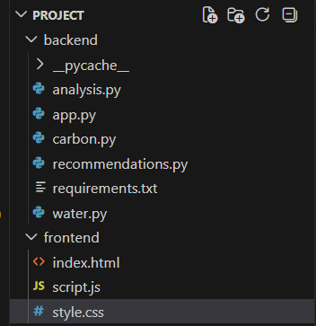

2. Data Collection
The system collects input data from users through a web form. The inputs include:
- Electricity consumption (kWh)
- Fuel usage (petrol, diesel, LPG)
- Food consumption (rice, wheat, chicken, vegetables)
These inputs represent real-life activities that contribute to carbon emissions and water usage.

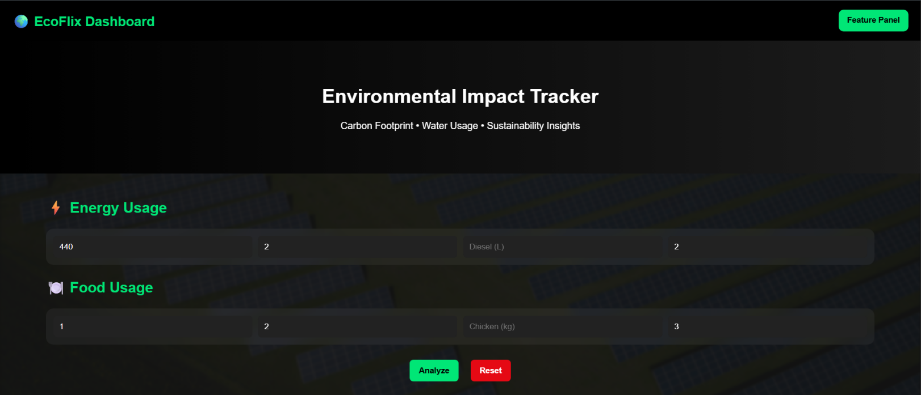

3. Data Processing
After data submission:
- The frontend sends input data to the backend using a POST API request.
- The backend receives the data in JSON format.
- The data is passed to different modules for processing.
The processing is divided into:
- Carbon emission calculation
- Water consumption calculation
- Data analysis and categorization

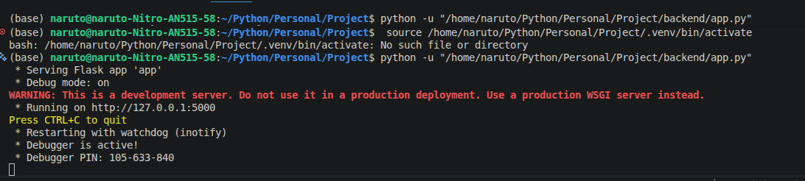

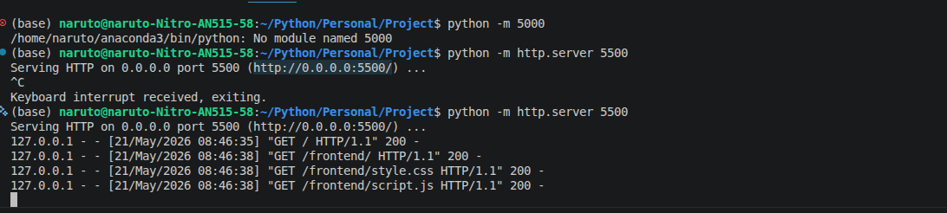

4. Calculation Method
The system uses a rule-based approach for calculations:
- Each input value is multiplied by predefined environmental factors
- Carbon emissions are calculated in terms of CO₂ equivalents
- Water usage is calculated based on food consumption data
- Results are grouped into categories such as energy, transport, and food
This ensures consistent and logical output generation.

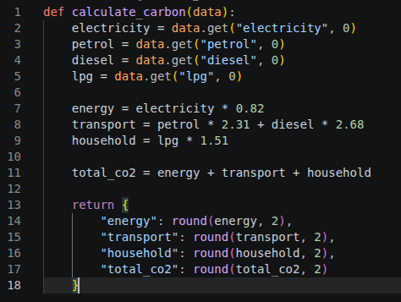

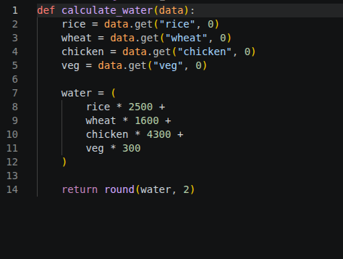

5. Result Generation
After processing:
- The backend sends results back to the frontend in JSON format
- The frontend displays:
  - Total carbon emission
  - Total water footprint
  - Category-wise breakdown
  - Suggestions for improvement
Visualization is done using charts for better understanding.

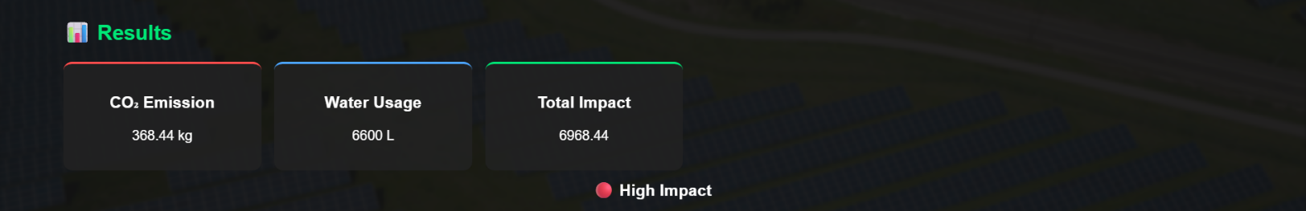

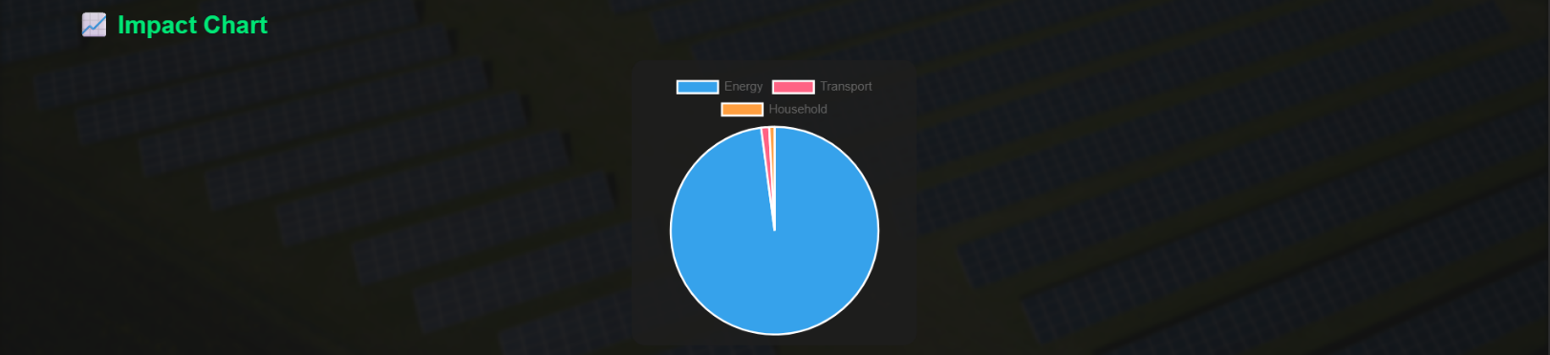

6. Feature Panel Integration
An additional feature called the Feature Panel is included in the system. It provides:
- Explanation of frontend and backend structure
- API communication flow
- Data processing steps
- Storage and connection workflow
This enhances the transparency and educational value of the project.
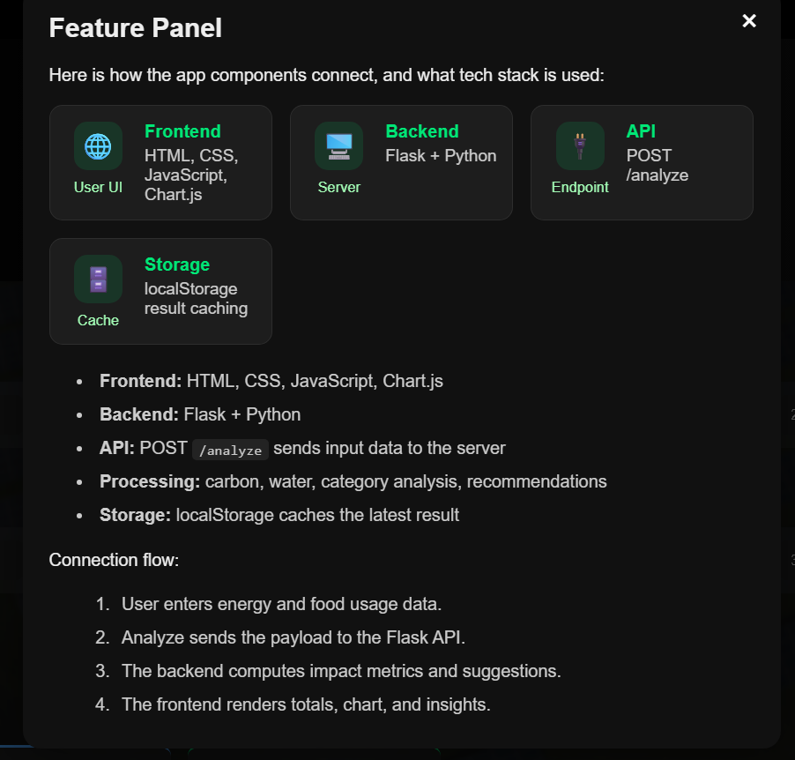

7. Workflow of the System
The overall working of the system can be summarized as:
User Input → Frontend Form → API Request → Backend Processing → Calculation Modules → JSON Response → Result Display

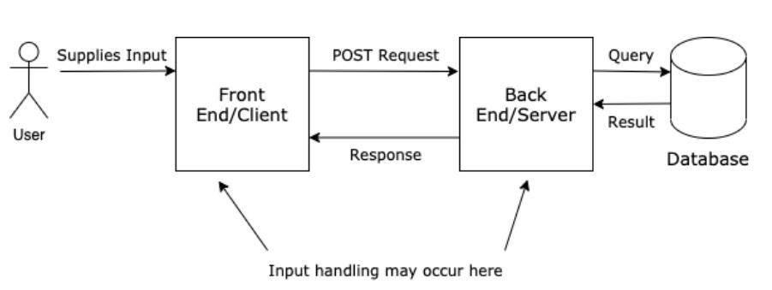

Flowchart

Includes Flowchart ( Start, Menu, Choice, Operations ) , and Class Diagram representing system structure. Sample class diagram –

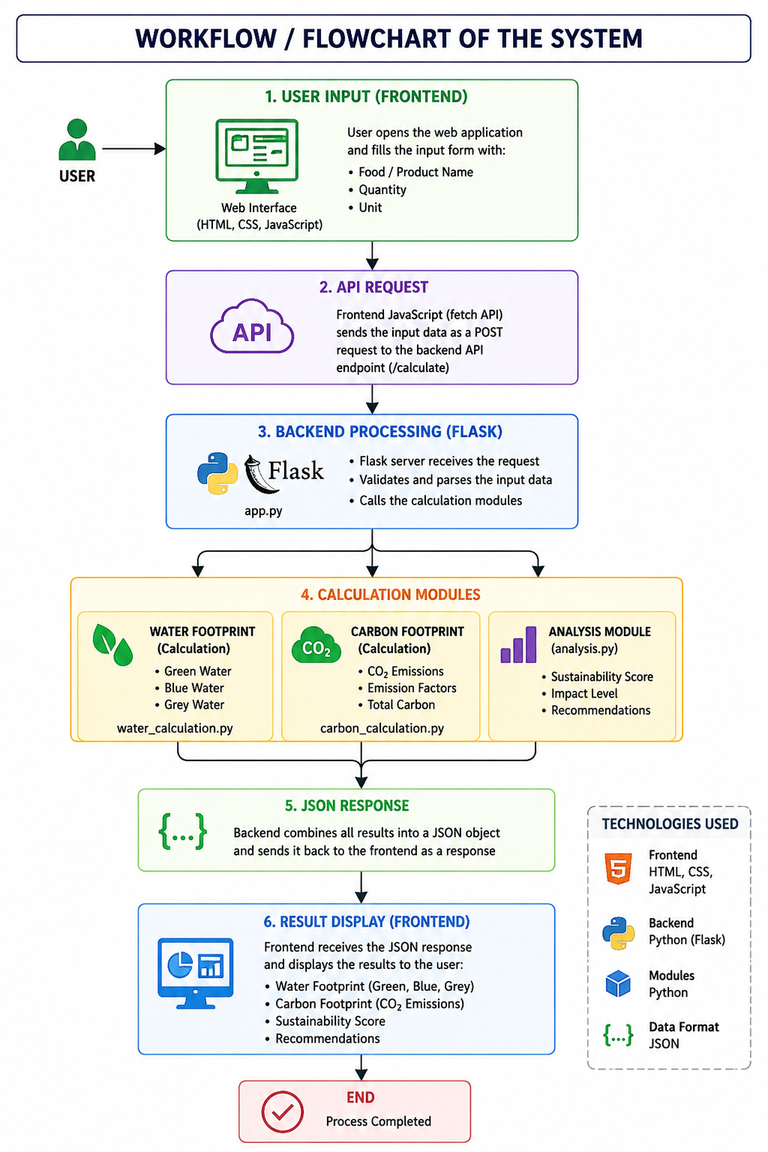

Implementation

1. Overview
The Energy Footprint Calculator is implemented as a full-stack web application using Python Flask for backend processing and HTML, CSS, and JavaScript for frontend development. The system follows a modular approach where each functionality is separated into different components for better maintainability and scalability.

2. Backend Implementation
The backend is developed using the Flask framework in Python. It handles all the logic related to data processing, calculation, and API communication.
Main Backend File: app.py
Responsibilities:
- Creates Flask application instance
- Defines API routes (/analyze)
- Receives input data from frontend
- Sends data to calculation modules
- Returns JSON response

Carbon Calculation Module (carbon.py)
- Calculates carbon emissions
- Uses predefined emission factors
- Processes electricity, petrol, diesel, LPG

Water Calculation Module (water.py)
- Calculates water footprint
- Processes food-related inputs
- Uses water usage constants for rice, wheat, chicken, vegetables

Analysis Module (analysis.py)
- Performs category-wise breakdown
- Divides impact into:
  - Energy
  - Transport
  - Household/food

Recommendation Module (recommendations.py)
- Generates eco-friendly suggestions
- Based on high usage patterns
- Encourages sustainable behavior

3. Frontend Implementation
The frontend is developed using:
- HTML → Structure of the application
- CSS → Styling and UI design
- JavaScript → API communication and dynamic updates

Features of Frontend
- Input form for user data
- “Analyze” button triggers API call
- Fetch API used to send POST request
- Displays results dynamically
- Shows:
  - CO₂ emissions
  - Water usage
  - Suggestions
- Pie chart visualization using Chart.js
- Feature Panel showing system architecture

4. API Communication
The system uses REST API communication:
Flow:
Frontend → POST request → Flask Backend
Backend → JSON response → Frontend
Example:
- Request: user inputs data
- Response: calculated carbon + water + suggestions

5. Data Processing Logic
The system uses rule-based calculation logic:
- Each input is multiplied by emission factor
- Values are summed for total impact
- Categories are separated for analysis
- Final output is structured in JSON format

6. Feature Panel Implementation
A special UI component called Feature Panel is added in the frontend.
It displays:
- Frontend architecture explanation
- Backend workflow
- API communication flow
- Storage system (local/browser storage)
- End-to-end system connection
This helps in understanding how the system works internally.

Gantt Chart

A Gantt chart is a project management tool used to represent the timeline of different activities involved in the development of a project. It helps in planning, scheduling, and tracking the progress of each phase of the project.
For the Energy Footprint Calculator, the development process was divided into multiple phases such as requirement analysis, system design, frontend development, backend development, integration, testing, and documentation.
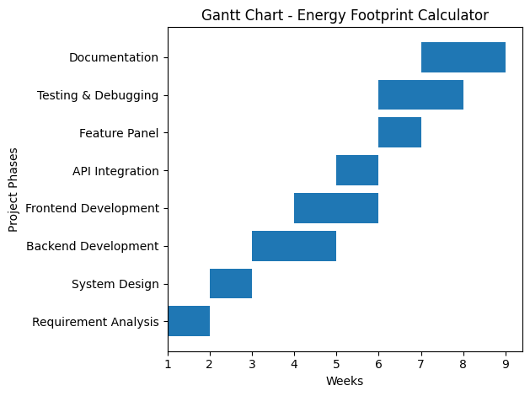

Explanation
- Week 1–2: Project planning, requirement gathering, and system design
- Week 3–4: Backend development using Flask and creation of calculation modules
- Week 4–5: Frontend development using HTML, CSS, and JavaScript
- Week 5: API integration between frontend and backend
- Week 6: Feature Panel development and UI enhancement
- Week 6–7: Testing, debugging, and error fixing
- Week 7–8: Final report writing and documentation

Conclusion

The Energy Footprint Calculator project successfully demonstrates the design and implementation of a full-stack web application aimed at analyzing and understanding the environmental impact of daily human activities. The system effectively calculates both carbon emissions and water consumption based on user inputs such as electricity usage, fuel consumption, and food intake, providing meaningful insights into an individual’s ecological footprint.
The integration of a Flask-based backend with a responsive frontend built using HTML, CSS, and JavaScript ensures smooth communication between the user interface and the processing system. The modular architecture of the backend, consisting of separate components for carbon calculation, water estimation, analysis, and recommendation generation, improves the maintainability and scalability of the project.
One of the key highlights of this system is its interactive dashboard, which presents results in a simple and visually appealing manner using charts and categorized breakdowns. Additionally, the inclusion of the Feature Panel enhances the transparency of the system by explaining the internal working of the frontend, backend, API communication, and data flow. This makes the project not only a functional application but also an educational tool for understanding system architecture.
The project also successfully achieves its objective of promoting environmental awareness by helping users identify the major contributors to their carbon and water footprint. The recommendation system further encourages users to adopt sustainable practices and reduce their environmental impact in daily life.
Overall, this project demonstrates how modern web technologies can be effectively used to solve real-world environmental problems. It provides a strong foundation for future enhancements such as machine learning integration, database support, and mobile application development. The Energy Footprint Calculator stands as a practical and meaningful step toward encouraging sustainable and eco-friendly living habits.

References
Research Papers / Journals

[1] M. M. Mekonnen and A. Y. Hoekstra, “The green, blue and grey water footprint of crops and derived crop products,” Water Footprint Network, 2025.
[2] A. Y. Hoekstra, “Water footprint assessment: Evolution of a new research field,” Springer, 2025.
[3] Food and Agriculture Organization (FAO), “Water use in agriculture and environmental impact,” 2025.
[4] Intergovernmental Panel on Climate Change (IPCC), “Climate change 2023: Mitigation of climate change – emission factors,” 2023.
[5] J. Poore and T. Nemecek, “Reducing food’s environmental impacts through producers and consumers,” Nature Food Journal.
[6] “Coupled water–energy–carbon footprint in agricultural systems,” Elsevier, 2026.
[7] “Assessment of agricultural sustainability using carbon and water footprint indicators,” Springer, 2025.
[8] “Comparative analysis of water and carbon footprints of food products,” Cambridge University Press, 2025.

